**Self Test Results**

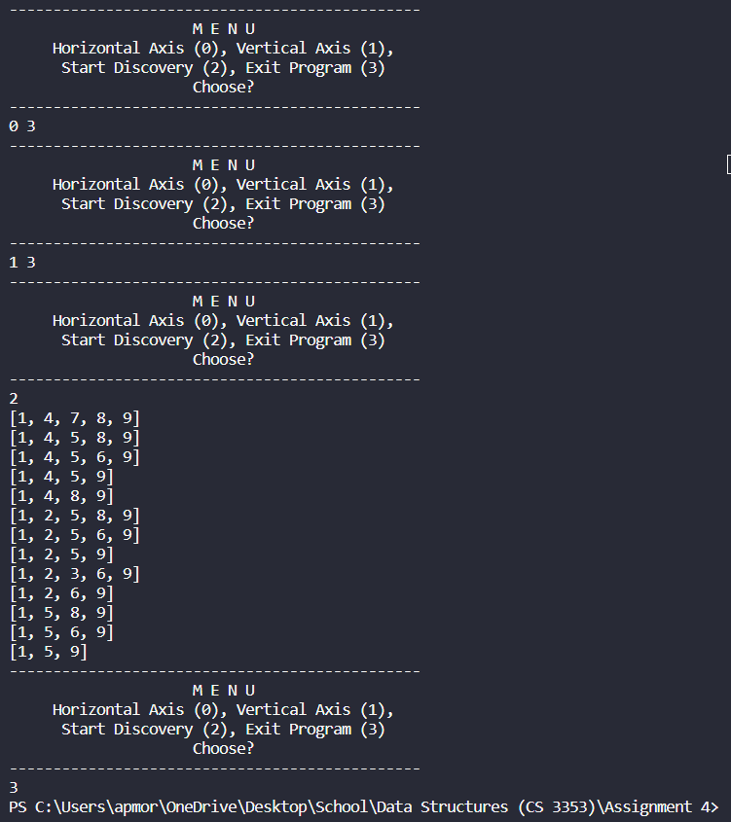

**AI Results**

I used ChatGPT to come up with an optimized version of my code segment dealing with finding all possible routes in a grid. The two suggestions it gave me were to rename the variable route and use a “helper function” instead of recursion. I did not know that route was a global variable in Java, so that was interesting information to learn. Although it said my code would be better without the use of recursion, the code it provided actually *did* have recursion in the “helper function” it created.

